Homework # 4 – Runs Test Tutorial on SPSS for Windows

Problem-01: A study on whether entering college students alter their weight during the freshman year was conducted. The students were weighed before and after the freshman year.

Hypotheses:
H_{o} - is that the weight stays the same during the freshman year.
H_{a} – is that the weight changed during the freshman year.

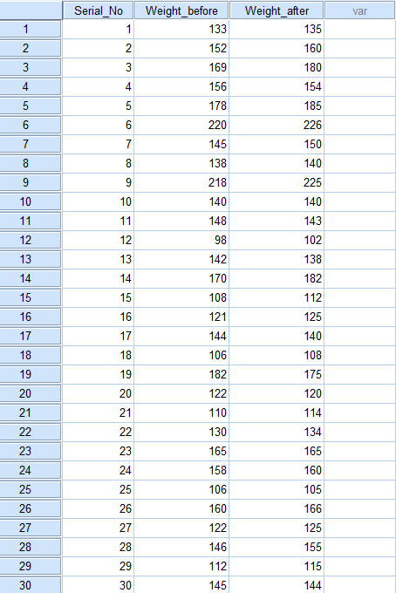
Problem-01 Manual calculation:
No. of Pluses = 20, No. of Minuses = 8, No change = 2
Thus, N = 28, and R_{o} = 8

From the sign table, for N = 28, R_{c} = 8 at .05 alpha level

As R_{o} = R_{c} , this implies to reject the null hypothesis that the weight stays the same during the freshman year.

This means a significant test result.

Moreover, there are more pluses than minuses.

Thus, the sign test result implies that the freshman gained weigh in their first year at college.

SPSS Output:
NPar Tests
Descriptive Statistics
 | N | Mean | Std. Deviation | Minimum | Maximum
Weight_before | 30 | 144.80 | 30.290 | 98 | 220
Weight_after | 30 | 147.43 | 31.578 | 102 | 226
Sign Test
Frequencies
 |  |  | N
Weight_after - Weight_before |  | Negative Differencesª | 8
 |  | Positive Differences^{b} | 20
 |  | Ties^{c} | 2
 |  | Total | 30
a. Weight_after < Weight_before
b. Weight_after > Weight_before
c. Weight_after = Weight_before
Test Statisticsª
 | Weight_after - Weight_before
Z | -2.079
Asymp. Sig. (2-tailed) | .038
a. Sign Test

Result:
The result indicates that 20 of them had increased their weights, eight had decreased and only two maintained their original weights. A sign test revealed that the difference was significant (N = 30, z = .038, p <.05), leading to rejecting the null and concluding that freshman gained weigh in their first year at college.

Problem-02: A sample of General Math students Verbal and Math ACT scores was analyzed to test if the students attained different scores in both.
Hypotheses:
H_{o} - is that there is no significant difference in the Verbal and Math ACT scores of students enrolled in General Math class.
H_{a} – is that there is a significant difference in the Verbal and Math ACT scores of students enrolled in General Math class.

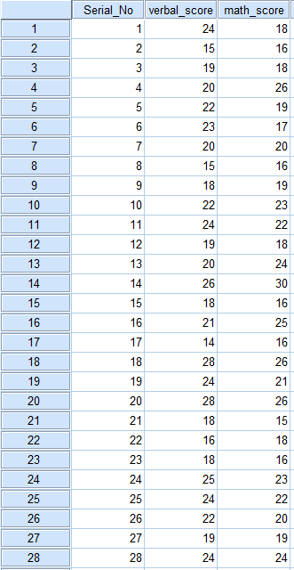
Problem-02 Manual calculation:
No. of Pluses = 10, No. of Minuses = 15, No change = 3
Thus, N = 25, and R_{o} = 10

From the sign table, for N = 25, R_{c} = 7 at .05 alpha level

As R_{o} > R_{c} , this implies to fail to reject the null hypothesis that there is no significant difference in the Verbal and Math ACT scores of students enrolled in General Math class.

This means a non-significant test result.

Thus, the sign test result implies that the student tend to score as high on the Verbal as they do on the Math ACT

SPSS Output:
NPar Tests
Descriptive Statistics
 | N | Mean | Std. Deviation | Minimum | Maximum
verbal_score | 28 | 20.9286 | 3.79013 | 14.00 | 28.00
math_score | 28 | 20.4643 | 3.93919 | 15.00 | 30.00

Sign Test
Frequencies
 |  |  |  | N
math_score - verbal_score |  | Negative Differencesª |  | 15
 |  | Positive Differences^{b} |  | 10
 |  | Ties^{c} |  | 3
 |  | Total |  | 28
a. math_score < verbal_score
b. math_score > verbal_score
c. math_score = verbal_score
Test Statistics^{b}
 | math_score - verbal_score
Exact Sig. (2-tailed) | .424ª
a. Binomial distribution used.
b. Sign Test

Result:
A sign test showed that their scores in Verbal were no significant difference from what they achieved in Math ACT, as (N = 28, z = .424, p >.05). I therefore, accept the null and conclude that the student tend to score as high on the Verbal as they do on the Math ACT.

Problem-03: A blind taste test was conducted with 45 coffee drinkers comparing fresh-brewed versus gourmet instant coffee.
Hypotheses:
H_{o} - is that coffee drinkers prefer no particular type of coffee.
H_{a} – is that coffee drinkers have specific preferences.
Problem-03 Manual calculation:
No. of instants = 14, No. of freshboweled = 26, No pref = 5
Thus, N = 40, and R_{o} = 14
From the sign table, for N = 40, R_{c} = 13 at .05 alpha level
As R_{o} > R_{c} , implies to fail to reject the null hypothesis that the coffee drinkers prefer no particular type of coffee.

This means a non-significant test result.
Thus, the sign test result implies that the coffee drinkers have no specific preferences.

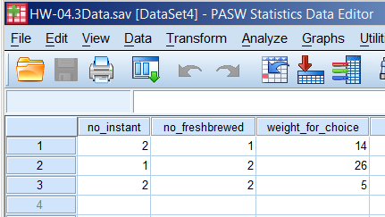

SPSS Output:
NPar Tests

Descriptive Statistics
 | N | Mean | Std. Deviation | Minimum | Maximum
no_instant | 45 | 1.4222 | .49949 | 1.00 | 2.00
no_freshbrewed | 45 | 1.6889 | .46818 | 1.00 | 2.00

Sign Test
Frequencies
 |  | N
no_freshbrewed - no_instant | Negative Differencesª | 14
no_freshbrewed - no_instant | Positive Differences^{b} | 26
no_freshbrewed - no_instant | Ties^{c} | 5
no_freshbrewed - no_instant | Total | 45
a. no_freshbrewed < no_instant
b. no_freshbrewed > no_instant
c. no_freshbrewed = no_instant

Test Statisticsª
 | no_freshbrewed - no_instant
Z | -1.739
Asymp. Sig. (2-tailed) | .082
a. Sign Test

Result:
The result showed that 14 preferred the gourmet instant, 26 were for the fresh-brewed and 5 were unbiased. A sign test revealed no significant difference in the tastes of the coffee drinkers, as (N = 45, z = .082, p >.05). With that result, I fail to reject the null hypothesis and conclude that the coffee drinkers have no specific preferences.
Problem-04:
A researcher interested in knowing whether a drug caused sleep administered it to 8 subjects. The researcher had them take the drug one night and a placebo another night with the order counterbalanced. The number of minutes it took each of the 8 subjects to fall asleep was recorded analyzed using a sign test.

Hypotheses:
H_{o} – is that the drugs do not change the time required to fall asleep.
H_{a} – is that the drugs change the time required to fall asleep.

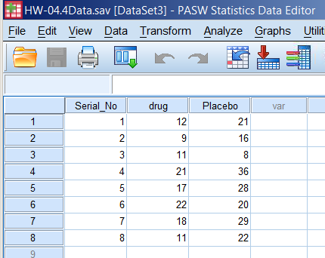
Problem-04 Manual calculation:
No. of Pluses = 6, No. of Minuses = 2, No change = 0
Thus, N = 8, and R_{o} = 2
From the sign table, for N = 8, R_{c} = 0 at .05 alpha level
As R_{o} > R_{c} , this implies to fail to reject the null hypothesis that the drug does not change the time required to fall asleep.

This means a non-significant test result.

Thus, the sign test result implies that the drugs do not change the time required to fall asleep.

SPSS Output:
NPar Tests
Descriptive Statistics
 | N | Mean | Std. Deviation | Minimum | Maximum
drug | 8 | 15.13 | 4.998 | 9 | 22
Placebo | 8 | 22.50 | 8.586 | 8 | 36

Sign Test

Frequencies
 |  | N
Placebo - drug | Negative Differencesª | 2
Placebo - drug | Positive Differences^{b} | 6
Placebo - drug | Ties^{c} | 0
Placebo - drug | Total | 8
a. Placebo < drug
b. Placebo > drug
c. Placebo = drug

Test Statistics^{b}
 | Placebo - drug
Exact Sig. (2-tailed) | .289ª
a. Binomial distribution used.
b. Sign Test

Result:
Results of the sign test showed that there was no significant change in the time required to fall asleep after taking the drug, as (N = 8, z = .289, p >.05). So, there was probably neither an increase nor a decrease in the time it took the subjects to fall asleep.

Problem-05: An psychology experiment studying the strength of support to a solution prescribed for a certain dilemma was carried out on 8 subjects. The treatment involved sharing and exchanging ideas about the dilemma.

Hypotheses:
H_{o} – is that the subjects’ support for the solution does not change.
H_{a} – is that the subjects’ opinion about the solution change.
Problem-05 Manual calculation:
No. of Pluses = 7, No. of Minuses = 0, No change = 0
Thus, N = 7, and R_{o} = 0
From the sign table, for N = 7, R_{c} = 0 at .05 alpha level
As R_{o} = R_{c} , this implies to reject the null hypothesis that that the subjects’ support for the solution does not change.

This means a significant test result.

Moreover, there are more pluses than minuses.
Thus, the sign test result implies that the subjects held the strong opinions about the solution to the dilemma after the discussion.

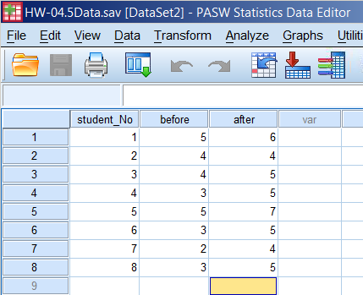

SPSS Output:
NPar Tests

Descriptive Statistics
 | N | Mean | Std. Deviation | Minimum | Maximum
before | 8 | 3.63 | 1.061 | 2 | 5
after | 8 | 5.13 | .991 | 4 | 7

Sign Test
Frequencies
 |  | N
after - before | Negative Differencesª | 0
after - before | Positive Differences^{b} | 7
after - before | Ties^{c} | 1
after - before | Total | 8
a. after < before
b. after > before
c. after = before

Test Statistics^{b}
 | after - before
Exact Sig. (2-tailed) | .016ª
a. Binomial distribution used.
b. Sign Test

Result:
A sign test on the strength of the subjects’ views about the solution, before and after the treatment showed no significant difference, as (N =8, z = .016, p <.05). I reject the null and conclude that the subjects held the strong opinions about the solution to the dilemma after the discussion.

Problem-06: An experiment was conducted to test the effect of a new chemical on the strength of wrapping paper. The paper’s strength before the treatment was found to be 1.4 units. Ten standard sheets of paper were measured for strength after treatment.

Hypotheses:
H_{o} – is that a new chemical does not change the strength of wrapping paper.
H_{a} – is that a new chemical treatment increases the strength of wrapping paper.

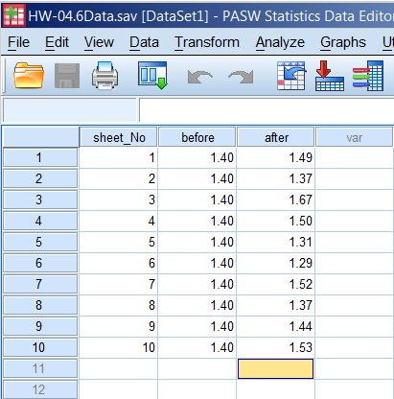
Problem-06 Manual calculation:
No. of Pluses = 6, No. of Minuses = 4, No change = 0
Thus, N = 10, and R_{o} = 4
From the sign table, for N = 10, R_{c} = 1 at .05 alpha level
As R_{o} > R_{c} , this implies to fail to reject the null hypothesis that that a new chemical does not change the strength of wrapping paper.
This means a non-significant test result.

Thus, the sign test result implies that the new chemical treatment probably does not change the strength of the wrapping paper.

SPSS Output:
NPar Tests
Descriptive Statistics
 | N | Mean | Std. Deviation | Minimum | Maximum
before | 10 | 1.4000 | .00000 | 1.40 | 1.40
after | 10 | 1.4490 | .11638 | 1.29 | 1.67

Sign Test
Frequencies
 |  |  |  | N
after - before | Negative Differencesª |  |  | 4
after - before | Positive Differences^{b} |  |  | 6
after - before | Ties^{c} |  |  | 0
after - before | Total |  |  | 10
a. after < before
b. after > before
c. after = before
Test Statistics^{b}
 |  | after - before
Exact Sig. (2-tailed) |  | .754ª
a. Binomial distribution used.
b. Sign Test

Result:
The results showed 6 increases and four decreases. A sign test was used to test for significance; it revealed no significant difference in the paper strength, as (N = 10, z = .754, p >.05). I therefore fail to reject the null hypothesis suggesting that the new chemical treatment probably does not change the strength of the wrapping paper.

Problem-07: Ten art historians rated two pictures for their artistic merit. The scale for rating was such that the higher the number the greater was the merit. The two paintings were: Mad Meg by Pieter Bruegel and Vanity by Hans Memling. The difference in rating was tested using a sign test.

Hypotheses:
H_{o} – is that the ratings for the two paintings are the same
H_{a} – is that the ratings of the two paintings differ.
Problem-07 Manual calculation:
No. of Pluses = 8, No. of Minuses = 1, No change = 0
Thus, N = 9, and R_{o} = 1
From the sign table, for N = 9, R_{c} = 1 at .05 alpha level
As R_{o} = R_{c} , this implies to reject the null hypothesis that that a new chemical does not change the strength of wrapping paper.

This means a significant test result.
Moreover, there are more pluses than minuses.
Thus, the sign test result implies that the art historians found the Mad Meg better than the Vanity.

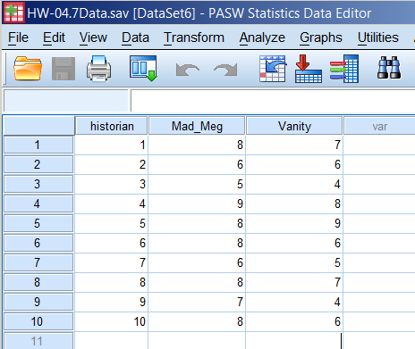

SPSS Output:
NPar Tests

Descriptive Statistics
 | N | Mean | Std. Deviation | Minimum | Maximum
Mad_Meg | 10 | 7.30 | 1.252 | 5 | 9
Vanity | 10 | 6.20 | 1.619 | 4 | 9
Sign Test
Frequencies
 |  | N
Vanity - Mad_Meg | Negative Differencesª | 8
Vanity - Mad_Meg | Positive Differences^{b} | 1
Vanity - Mad_Meg | Ties^{c} | 1
Vanity - Mad_Meg | Total | 10
a. Vanity < Mad_Meg
b. Vanity > Mad_Meg
c. Vanity = Mad_Meg

Test Statistics^{b}
 | Vanity - Mad_Meg
Exact Sig. (2-tailed) | .039ª
a. Binomial distribution used.
b. Sign Test

Result:
It reveals a significant difference between the merits of the two paintings, as (N = 10, z = .039, p <.05). I reject the null and conclude that the art historians found the Mad Meg better than the Vanity.

Problem-08: A new fertilizer was introduced to 12 plants in an experiment intended to study the effect of growing plants under controlled conditions. Previous experiments produced plants of an average height of 12cm. Heights of the 12 plants after treatment were tested against the average height of 12cm.

Hypotheses:
H_{o} – is that the heights of the plant remained the same.
H_{a} – is that the heights of the plants changed.

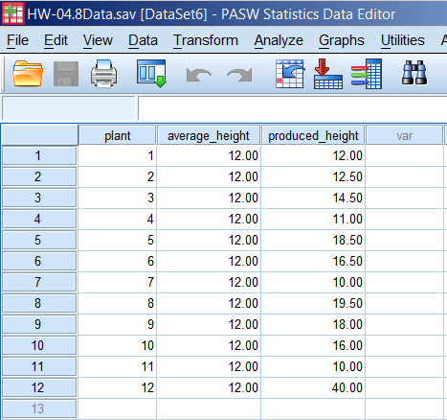
Problem-08 Manual calculation:
No. of Pluses = 8, No. of Minuses = 3, No change = 0
Thus, N = 11, and R_{o} = 3

From the sign table, for N = 11, R_{c} = 1 at .05 alpha level

As R_{o} > R_{c} , implies to fail to reject the null hypothesis that the heights of the plant remained the same.

This means a non-significant test result.

Thus, the sign test result implies that the new fertilizer had no effect in changing heights of plants.

SPSS Output:
NPar Tests
Descriptive Statistics
 | N | Mean | Std. Deviation | Minimum | Maximum
average_height | 12 | 12.0000 | .00000 | 12.00 | 12.00
produced_height | 12 | 16.5417 | 8.10572 | 10.00 | 40.00

Sign Test
Frequencies
 |  |  |  | N
produced_height - average_height |  | Negative Differencesª |  | 3
 |  | Positive Differences^{b} |  | 8
 |  | Ties^{c} |  | 1
 |  | Total |  | 12
a. produced_height < average_height
b. produced_height > average_height
c. produced_height = average_height
Test Statistics^{b}
 | produced_height - average_height
Exact Sig. (2-tailed) | .227ª
a. Binomial distribution used.
b. Sign Test

Result:
The result of a sign test shows that the heights do not significantly differ from the average height, as (N = 12, z = .227, p >.05). So, I fail to reject the null hypothesis that implies that the new fertilizer has no effect in changing heights of plants.

